**Dynamic Weather Web Application**

**Web Technology and Cyber Security Project**

**Even Semester, 2021**

**GROUP MEMBERS**

|  |  |
| --- | --- |
| **NAME** | **ENROLLMENT NUMBER** |
| AYUSH PANDEY | 9918103213 |
| BHUVAN SINGH | 9918103251 |
| YASH MANGAL | 9918103235 |



**Department of CSE/IT**

**Jaypee Institute of Information Technology (Sector-128),Noida**

**Abstract**

The project is aimed at developing a dynamic and responsive weather web app using single page architecture. Though there are many applications being developed across the globe many of them are clunky and fail to provide basic functionality. Hence we have taken up a basic idea of a weather monitoring website and challenge ourselves to develop a standard application. The web app shall have the features of choosing your city and accordingly fetch the weather details from an API for the current date. It will also have an ‘About’ section for the details about the authors of the website.

**Scope of the Project**

**Functional Requirements**

1. The user must be able to search for the city of their choice.   
     
   * Check whether the city entered is a valid location.
   * Check whether the entry field is left empty.
2. The website must fetch the required weather details using the API in real time.  
     
   * Display the temperature
   * Display the weather condition i.e. Rainy/Sunny/Cloudy
3. The website must have a Home/Landing page for the user.
4. The website must have an About section with the details of the authors of the website.
5. Error handling for common errors like Error 404 Page Not Found.
6. Must have Responsive Design i.e.  must function for various screen sizes.

**Non Functional Requirements**

1. EaseofUse
2. Dynamic
3. Responsive
4. Speed of Performance

**Tools and Technologies Used**

**HTML -** Hypertext Markup Language (HTML) is the standard markup language for documents designed to be displayed in a web browser.

**Bootstrap 4 -** The most popular HTML, CSS, and JS library in the world.

**Node.js -** Node.js open-source, cross-platform, back-end JavaScript runtime environment that runs on the V8 engine and executes JavaScript code outside a web browser.

**Express.js -** Express.js, or simply Express,is a back end web application framework for Node.js, released as free and open-source software under the MIT License. It is designed for building applications and APIs.

**Real time API -** An application programming interface (API) is a computing interface that defines interactions between multiple software intermediaries.

**Screenshots**

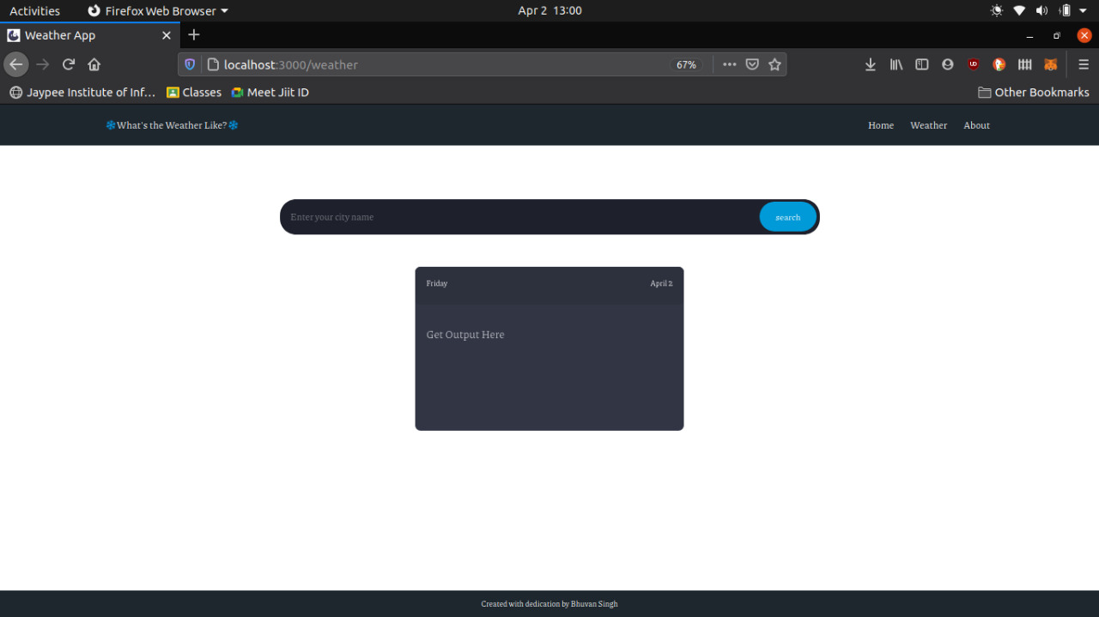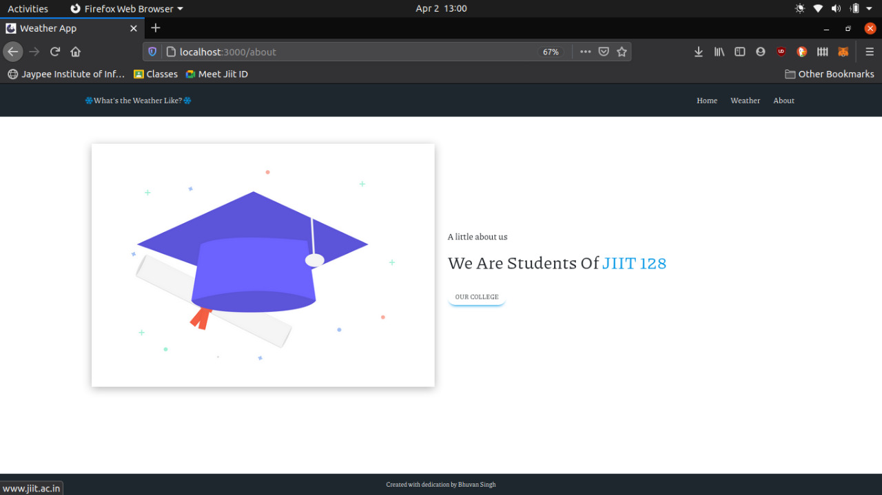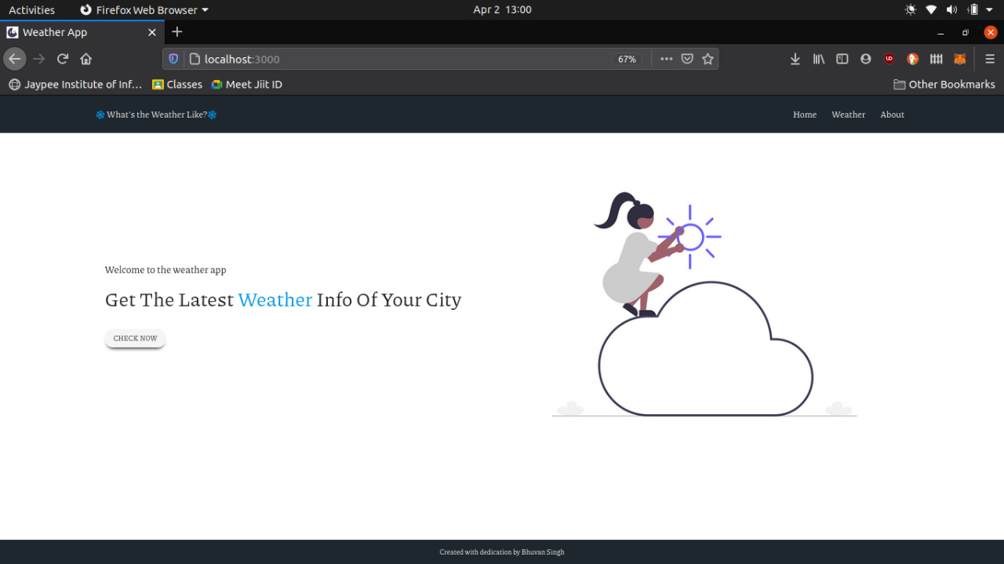

**Implementation**

package.json

{

 "name": "expressweb",

 "version": "1.0.0",

 "description": "",

 "main": "index.js",

 "dependencies": {

   "express": "^4.17.1",

   "hbs": "^4.1.1"

 },

 "devDependencies": {},

 "scripts": {

   "test": "echo \"Error: no test specified\" && exit 1"

 },

 "author": "bhuvan",

 "license": "ISC"

}

Style.css

@import url('https://fonts.googleapis.com/css2?family=Piazzolla:ital,wght@0,200;0,300;0,400;1,900&display=swap');

*{

   margin: 0;

   padding: 0;

   box-sizing: border-box;

   font-family: "Piazzolla", serif;

}

:root {

   --main-bg: #1e272e;

   --main-color: #0097e6;

}

html {

 font-size: 62.5%;

}

body {

   height: 100vh;

   display: flex;

   flex-direction: column;

}

.row {

   margin: 0;

}

.main_menu {

   background-color: var(--main-bg);

}

.navbar {

   color: #fff;

   background-color: var(--main-bg);

   padding: 2rem 0;

}

.navbar li{

   margin-left: 2rem;

}

.navbar a {

   color: #fff;

   font-size: 1.8rem;

}

.navbar a:hover {

   color: var(--main-color);

}

.navbar-toggler{

   background-color: grey;

}

.fa-snowflake{

   transition: all linear;

   animation: rot 2s linear infinite;

   color: var(--main-color);

}

@keyframes rot{

   0%{

       transform: rotate(0deg);

   }

   100%{

       transform: rotate(360deg);

   }

}

.main_header_left{

   height: 70rem;

   display: flex;

   flex-direction: column;

   justify-content: center;

   align-items: flex-start;

}

.main_header_left p{

   font-size: 2rem;

}

.main_header_left h1{

   font-size: 4rem;

   margin: 1rem 0 4rem 0;

   text-transform: capitalize;

}

.main_header_left .text_clr{

   color: var(--main-color);

}

.main_header_left button{

   border: none;

   padding: 0.8rem 1.8rem;

   font-size: 1.4rem;

   border-radius: 2rem;

   text-transform: uppercase;

   box-shadow: 0 8px 6px -6px #000;

   outline: none;

}

.main_header_left button:hover{

   box-shadow: 0 8px 6px -6px var(--main-color);

}

.main_header_right{

   height: 70rem;

   display: flex;

   flex-direction: column;

   justify-content: center;

   align-items: flex-start;

}

.main_header_right figure img {

   filter: drop-shadow(0 0.5rem 1rem rgba(0, 0, 0, 0.3));

 }

 /* temp input fields style code */

.temp_form {

   width: 60%;

   position: relative;

   margin: 10rem auto 6rem;

 }

  .temp_form input[type="text"] {

   width: 100%;

   padding: 2rem 5rem 2rem 2rem;

   background: #1e202b;

   color: white;

   outline: none;

   border: none;

   font-size: 1.7rem;

   border-radius: 3rem;

 }

  ::placeholder {

   color: #bfc1c8;

 }

  .temp_form input[type="submit"] {

   position: absolute;

   top: 5px;

   right: 5px;

   bottom: 5px;

   border: none;

   background: #009ad8;

   padding: 0 3rem;

   border-radius: 3rem;

   color: white;

   font-size: 1.6rem;

 }

  .temp_form input[type="submit"]:hover {

   color: #009ad8;

   background-color: #fff;

 }

  /* temp detials show here */

  .tempInformation {

   width: 50rem;

   margin: auto;

   min-height: 20rem;

   background-color: #323544;

   border-radius: 1rem;

   /* padding: 1rem; */

   font-family: "Roboto", sans-serif;

 }

  .top_layer {

   width: 100%;

   height: 20%;

   /* background-color: red; */

   background-color: #2d303d;

   display: flex;

   justify-content: space-between;

   align-items: center;

   border-radius: 1rem;

 }

  .top_layer p {

   color: #fff;

   font-weight: 300;

   padding: 2rem;

   font-size: 1.4rem;

 }

  .main_layer {

   width: 100%;

   height: 80%;

   display: flex;

   flex-direction: column;

   padding: 2rem;

 }

  .main_layer #city_name {

   padding: 2rem 0;

   color: #bfc1c8;

   font-weight: 300;

   font-size: 2rem;

 }

  .main_layer .middle_layer {

   display: flex;

   justify-content: space-around;

   color: #fff;

 }

  .main_layer .middle_layer p,

 .main_layer .middle_layer .fa {

   font-size: 7rem;

   font-weight: 900;

 }

  .fa {

   color: #009ad8;

 }

  sup {

   font-size: 6rem;

   margin-top: -2rem;

 }

  .data_hide {

   visibility: hidden;

   transition: all 0.3s linear;

 }

  /* error page style */

 .errimg img {

   width: 60rem;

   height: 30rem;

 }

/* footer styles */

footer{

   width: 100%;

   background-color: var(--main-bg);

   margin-top: auto;

}

footer p{

   margin: 0;

   text-align: center;

   color: #fff;

   line-height: 5rem;

   font-size: 1.4rem;

}

/* responsive code */

@media (max-width: 768px) {

   .main_header_left {

     height: auto;

     margin: 5rem 0;

   }

    .main_header_right {

     height: auto;

     margin-top: 3rem;

   }

    .temp_form {

     width: auto;

   }

    .tempInformation {

     width: auto;

   }

    .main_layer .middle_layer p,

   .main_layer .middle_layer .fa {

     font-size: 5rem;

   }

 }

main.js

const cityName = document.getElementById('cityName');

const submitBtn = document.getElementById('submitBtn');

const city_name = document.getElementById('city_name');

const temp_real_val = document.getElementById('temp_real_val');

const temp_status = document.getElementById('temp_status');

const datahide = document.querySelector('.middle_layer');

const getInfo = async(event) =>{

   event.preventDefault();

   let cityVal = cityName.value;

   if(cityVal === ""){

       city_name.innerText = `Please write the name before search`;

       datahide.classList.add('data_hide');

   }else{

       try{

           let url = `http://api.openweathermap.org/data/2.5/weather?q=${cityVal}&units=metric&appid=b14425a6554d189a2d7dc18a8e7d7263`;

           const response = await fetch(url);

           const data = await response.json();

          const arrData = [data];

          city_name.innerText = `${arrData[0].name}, ${arrData[0].sys.country}`;

          temp_real_val.innerText = arrData[0].main.temp;

           const tempMood = arrData[0].weather[0].main;

           //condition to check sunny or cloudy

           if (tempMood == "Clear") {

               temp_status.innerHTML =

                   "<i class='fas  fa-sun' style='color: #eccc68;'></i>";

               } else if (tempMood == "Clouds") {

               temp_status.innerHTML =

                   "<i class='fas  fa-cloud' style='color: #f1f2f6;'></i>";

               } else if (tempMood == "Rain") {

               temp_status.innerHTML =

                   "<i class='fas  fa-cloud-rain' style='color: #a4b0be;'></i>";

               } else {

               temp_status.innerHTML =

                   "<i class='fas  fa-sun' style='color:#eccc68;'></i>";

               }

               datahide.classList.remove('data_hide');

       }catch{

           city_name.innerText = `Please enter the city name properly`;

           datahide.classList.add('data_hide');

       }

   }

}

submitBtn.addEventListener('click', getInfo);

app.js

const express = require('express');

const path = require('path');

const hbs = require('hbs');

const app = express();

const port = process.env.PORT || 3000 ;

//public static path

const static_path = path.join(__dirname, "../public");

const template_path = path.join(__dirname, "../templates/views");

const partials_path = path.join(__dirname, "../templates/partials");

app.set('view engine', 'hbs');

app.set('views',template_path);

hbs.registerPartials(partials_path);

app.use(express.static(static_path));

//routing

app.get("", (req,res)=>{

   res.render("index")

})

app.get("/about", (req,res)=>{

   res.render("about")

})

app.get("/weather", (req,res)=>{

   res.render("weather")

})

app.get("*", (req,res)=>{

   res.render("404error",{

       errorMsg: 'Oops! Page not found'

   })

})

app.listen(port , ()=> {

   console.log(`listening on the port at ${port}`)

})

Templates/Partials

footer.hbs

<footer>

       <p>

           Created with dedication by Bhuvan Singh

       </p>

   </footer>

headerlinks.hbs

<meta charset='UTF-8'>

   <meta name = 'viewport' content = "width=device-width, initial scale=1.0">

   <!-- Latest compiled and minified CSS -->

   <link rel="stylesheet" href="https://maxcdn.bootstrapcdn.com/bootstrap/4.5.2/css/bootstrap.min.css">

   <link rel="stylesheet" href="https://cdnjs.cloudflare.com/ajax/libs/font-awesome/5.10.0/css/all.min.css" integrity="sha512-PgQMlq+nqFLV4ylk1gwUOgm6CtIIXkKwaIHp/PAIWHzig/lKZSEGKEysh0TCVbHJXCLN7WetD8TFecIky75ZfQ==" crossorigin="anonymous" />

   <!-- jQuery library -->

   <script src="https://ajax.googleapis.com/ajax/libs/jquery/3.5.1/jquery.min.js"></script>

   <!-- Popper JS -->

   <script src="https://cdnjs.cloudflare.com/ajax/libs/popper.js/1.16.0/umd/popper.min.js"></script>

   <!-- Latest compiled JavaScript -->

   <script src="https://maxcdn.bootstrapcdn.com/bootstrap/4.5.2/js/bootstrap.min.js"></script>

   <title>

       Weather App

   </title>

   <link rel="stylesheet" href="css/style.css">

   <link rel="shortcut icon" href="images/logo.png" type="image/png">

navbar.hbs

<div class="container-fluid main_menu">

       <div class="row">

           <div class="col-md-10 col-12 mx-auto">

               <nav class="navbar navbar-expand-lg ">

                   <a class="navbar-brand" href="/"> <i class="far fa-snowflake"></i> What's the Weather Like? <i class="far fa-snowflake"></i></a>

                   <button class="navbar-toggler" type="button" data-toggle="collapse" data-target="#navbarSupportedContent" aria-controls="navbarSupportedContent" aria-expanded="false" aria-label="Toggle navigation">

                     <span class="navbar-toggler-icon"></span>

                   </button>

                   <div class="collapse navbar-collapse" id="navbarSupportedContent">

                     <ul class="navbar-nav ml-auto">

                       <li class="nav-item active">

                         <a class="nav-link" href="/">Home <span class="sr-only">(current)</span></a>

                       </li>

                       <li class="nav-item">

                         <a class="nav-link" href="/weather">Weather</a>

                       </li>

                       <li class="nav-item">

                         <a class="nav-link" href="/about">About</a>

                       </li>

                     </ul>

                   </div>

                 </nav>

           </div>

       </div>

   </div>

templates/views

404error.hbs

<div class="container-fluid main_menu">

       <div class="row">

           <div class="col-md-10 col-12 mx-auto">

               <nav class="navbar navbar-expand-lg ">

                   <a class="navbar-brand" href="/"> <i class="far fa-snowflake"></i> What's the Weather Like? <i class="far fa-snowflake"></i></a>

                   <button class="navbar-toggler" type="button" data-toggle="collapse" data-target="#navbarSupportedContent" aria-controls="navbarSupportedContent" aria-expanded="false" aria-label="Toggle navigation">

                     <span class="navbar-toggler-icon"></span>

                   </button>

                   <div class="collapse navbar-collapse" id="navbarSupportedContent">

                     <ul class="navbar-nav ml-auto">

                       <li class="nav-item active">

                         <a class="nav-link" href="/">Home <span class="sr-only">(current)</span></a>

                       </li>

                       <li class="nav-item">

                         <a class="nav-link" href="/weather">Weather</a>

                       </li>

                       <li class="nav-item">

                         <a class="nav-link" href="/about">About</a>

                       </li>

                     </ul>

                   </div>

                 </nav>

           </div>

       </div>

   </div>

about.hbs

<!DOCTYPE html>

<html lang = 'en'>

<head>

       {{>headerlinks}}

</head>

<body>

 {{>navbar}}

   <!--main header-->

   <div class="container-fluid main_header">

       <div class="row">

           <div class="col-md-10 col-12 mx-auto">

               <div class="row">

                   <!-- left side div -->

                   <div class="col-md-6 col-12 main_header_right align-items-center">

                       <figure>

                           <img src="images/college.png" alt="Bhuvan" class="img-fluid" title="Web Tech Project">

                       </figure>

                   </div>

                   <!-- right side div -->

                   <div class="col-md-6 col-12 main_header_left">

                       <p>A little about us</p>

                       <h1>We are students of <span class="text_clr"> JIIT 128</span> </h1>

                       <a href="http://www.jiit.ac.in/" target = "_college"><button>our college</button></a>

                   </div>

               </div>

           </div>

       </div>

   </div>

   <!-- footer -->

   {{>footer}}

</body>

</html>

index.hbs

<!DOCTYPE html>

<html lang = 'en'>

<head>

   {{>headerlinks}}

</head>

<body>

   {{>navbar}}

   <!--main header-->

   <div class="container-fluid main_header">

       <div class="row">

           <div class="col-md-10 col-12 mx-auto">

               <div class="row">

                   <!-- left side div -->

                   <div class="col-md-6 col-12 main_header_left">

                       <p>Welcome to the weather app</p>

                       <h1>Get the latest <span class="text_clr"> Weather</span> Info of your City</h1>

                       <a href="/weather"><button>check now</button></a>

                   </div>

                   <!-- right side div -->

                   <div class="col-md-6 col-12 main_header_right">

                       <div id="carouselExampleIndicators" class="carousel slide" data-ride="carousel">

                           <ol class="carousel-indicators">

                             <li data-target="#carouselExampleIndicators" data-slide-to="0" class="active"></li>

                             <li data-target="#carouselExampleIndicators" data-slide-to="1"></li>

                             <li data-target="#carouselExampleIndicators" data-slide-to="2"></li>

                           </ol>

                           <div class="carousel-inner">

                             <div class="carousel-item active">

                               <img class=" w-100" src="images/bg1.png" alt="First slide">

                             </div>

                             <div class="carousel-item">

                               <img class=" w-100" src="images/bg2.png" alt="Second slide">

                             </div>

                             <div class="carousel-item">

                               <img class=" w-100" src="images/bg3.png" alt="Third slide">

                             </div>

                           </div>

                           <a class="carousel-control-prev" href="#carouselExampleIndicators" role="button" data-slide="prev">

                             <span class="carousel-control-prev-icon" aria-hidden="true"></span>

                             <span class="sr-only">Previous</span>

                           </a>

                           <a class="carousel-control-next" href="#carouselExampleIndicators" role="button" data-slide="next">

                             <span class="carousel-control-next-icon" aria-hidden="true"></span>

                             <span class="sr-only">Next</span>

                           </a>

                         </div>

                   </div>

               </div>

           </div>

       </div>

   </div>

   <!-- footer -->

   {{>footer}}

</body>

</html>

weather.hbs

<!DOCTYPE html>

<html lang="en">

<head>

   {{>headerlinks}}

</head>

<body>

   {{>navbar}}

   <!-- main header -->

   <div class="containter-fluid main_header">

       <div class="row">

           <div class="col-md-10 col-12 mx-auto">

               <div class="main_content">

                   <form class="temp_form">

                       <input type="text" id="cityName" placeholder="Enter your city name" autocomplete="off">

                       <input type="submit" value="search" id="submitBtn">

                   </form>

               </div>

               <div class="tempInformation">

                   <div class="top_layer">

                       <p id="day">Friday</p>

                       <p id="today_date">2 April</p>

                   </div>

                   <div class="main_layer ">

                       <p id="city_name">Get Output Here</p>

                       <div class="middle_layer data_hide">

                           <p id="temp"><span id="temp_real_val">0</span> <sup>o</sup>C</p>

                           <p id="temp_status"> <i class="fa fa-cloud" aria-hidden="true"></i> </p>

                       </div>

                   </div>

               </div>

           </div>

       </div>

   </div>

   <!-- footer code -->

   {{>footer}}

   <script src="js/main.js"></script>

   <script>

       const getCurrentDay = () => {

           let weekday = new Array(7);

           weekday[0] = "Sunday";

           weekday[1] = "Monday";

           weekday[2] = "Tuesday";

           weekday[3] = "Wed";

           weekday[4] = "Thursday";

           weekday[5] = "Friday";

           weekday[6] = "Saturday";

           let currentTime = new Date();

           days = weekday[currentTime.getDay()];

           let day = document.getElementById('day');

           day.innerText = days;

       };

       getCurrentDay();

   </script>

</body>

</html>

**References**

1. **Wikipedia** for gathering knowledge about the project.
2. **Slide share** for gathering tools of the project.
3. **College Modules** for gathering technical knowledge.